KONFIGURASI REVERSE PROXY PADA VPS CENTOS7
1. Persiapan
Web1 | Web2
OS: Centos7 | OS: Centos7
IP: 117.53.44.123 | IP: 117.53.44.123
domain: client1.leon36.web.id | domain: clieent2.leon36.web.id
apache2 | apache2
Php7.1 | php7.1
Nextcloud | Magento
PORT 1080 | PORT 1080

2. Install paket php
yum install http://rpms.remirepo.net/enterprise/remi-release-7.rpm
yum-config-manager --enable remi-php71
yum -y install php php-common php-opcache php-mcrypt php-cli php-gd php-curl php-mysqlnd php-dom php-curl php-zip php-mbstring php-xml php-xmlreader php-simplexml php-bcmath php-soap php-amqplib

3. Install apache
yum -y install httpd
systemctl start httpd && systemctl enable httpd
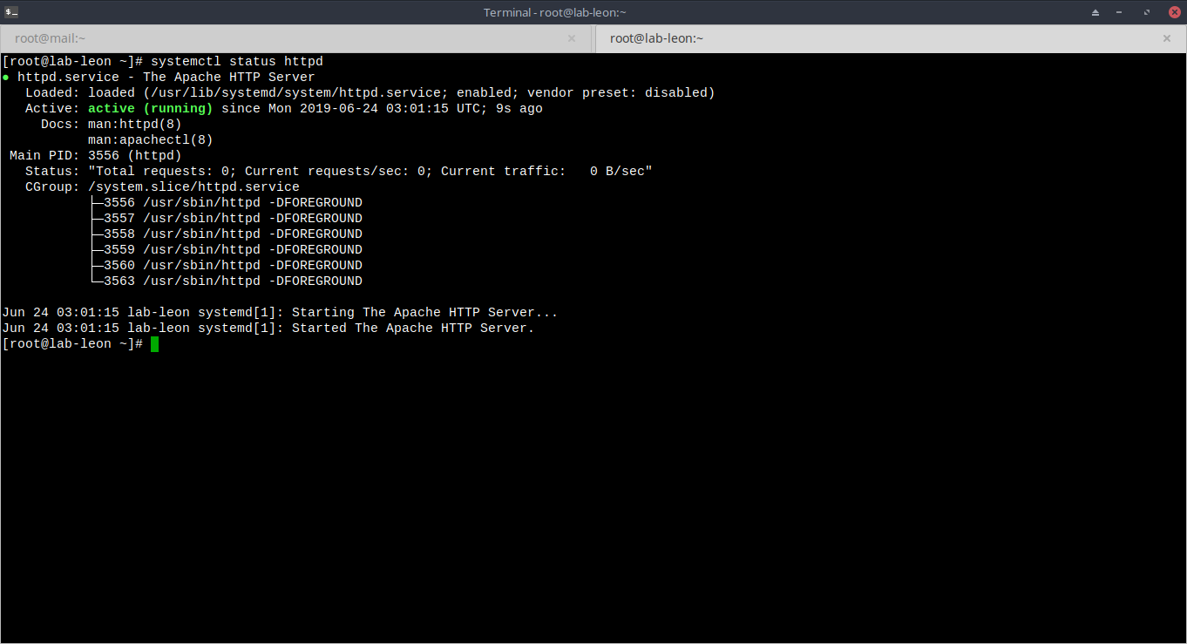
4. Install mariadb-server
vim /etc/yum.repos.d/mariadb.repo
........
[mariadb]
name = MariaDB
baseurl = http://yum.mariadb.org/10.1/centos7-amd64
gpgkey=https://yum.mariadb.org/RPM-GPG-KEY-MariaDB
gpgcheck=1
.....…
yum update -y
yum install -y mariadb-server
systemctl start mariadb && systemctl enable mariadb
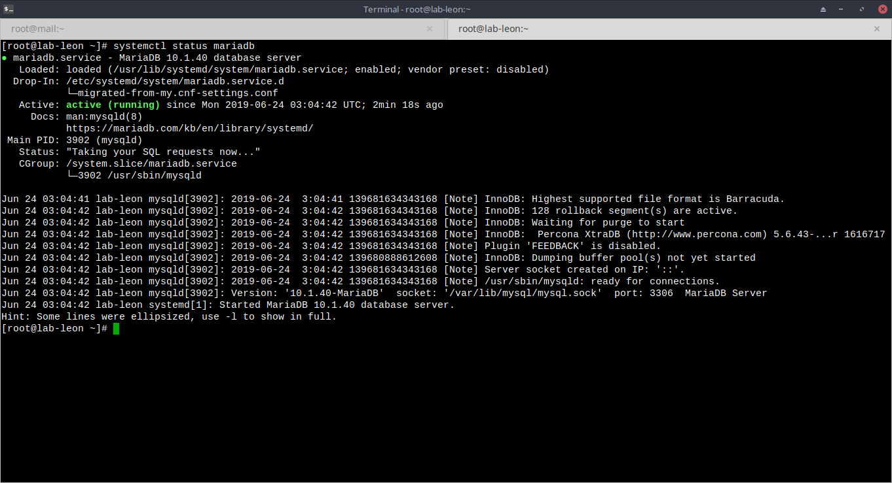
5. Ganti listen port apache menjadi 1080
vim /etc/httpd/conf/httpd.conf
…………………..
listen 80 -> listen 1080
………………….
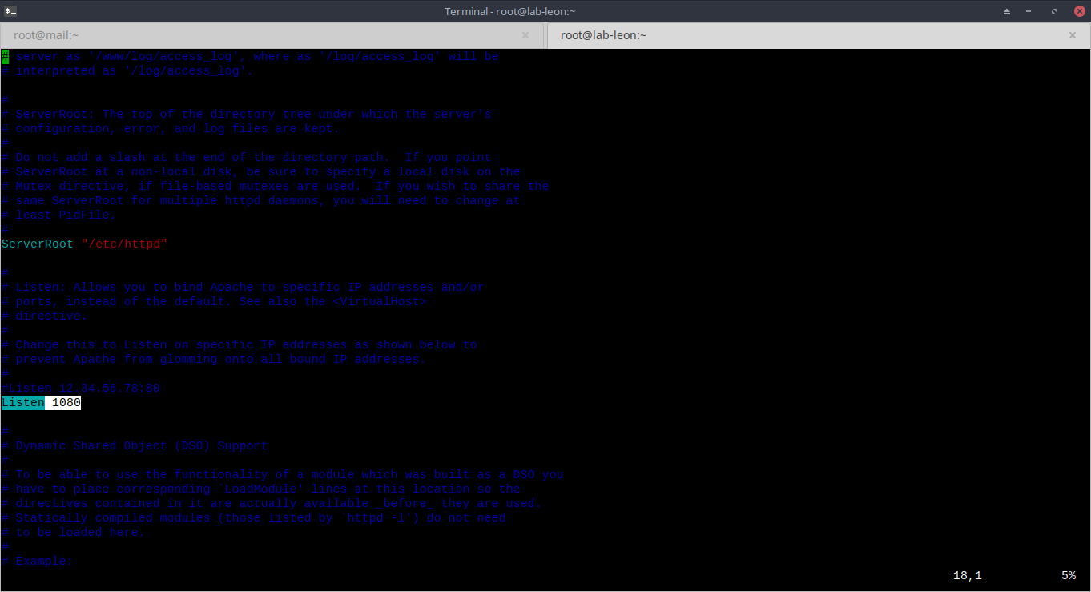
6. Buat dir sites-available & sites-enabled
mkdir /etc/httpd/sites-available
mkdir /etc/httpd/sites-enabled
echo "IncludeOptional sites-enabled/*.conf" >> /etc/httpd/conf/httpd.conf

7. Buat database Nextcloud
mysql -u root -p
create database nextcloud;
GRANT ALL PRIVILEGES ON nextcloud.* TO 'nextcloud'@'localhost' IDENTIFIED BY 'sFXasd@sa';
FLUSH PRIVILEGES;
show databases;
exit;
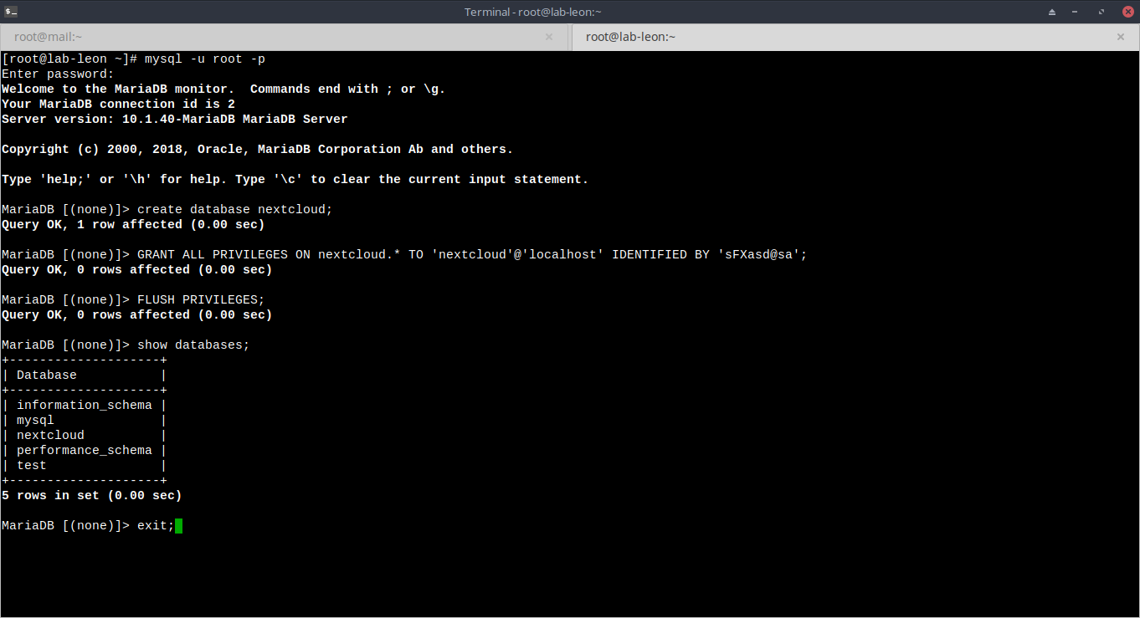
8. Download Nextcloud
wget https://download.nextcloud.com/server/releases/nextcloud-14.0.4.zip
unzip nextcloud-14.0.4.zip
mv nextcloud /var/www/html/web1

9. Ganti permision dan kepemilikan direktori
chmod -R 755 /var/www/html/web1
chown -R apache:apache /var/www/html/web1
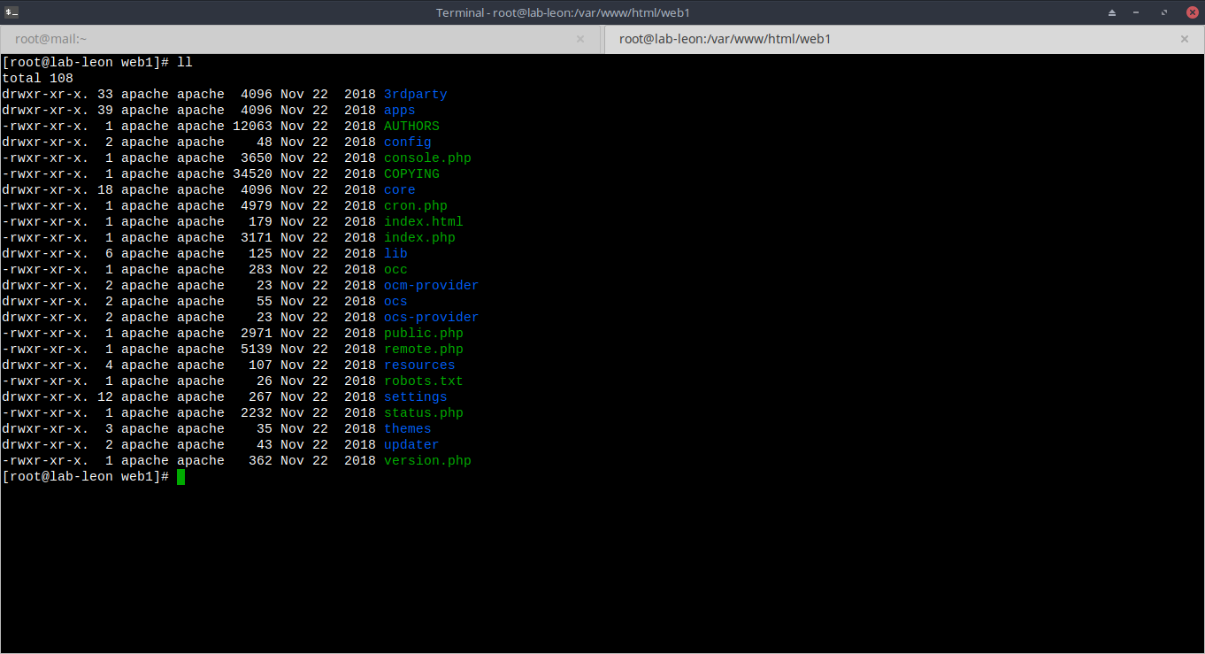
10. Buat virtualhost untuk Nextcloud
vim /etc/httpd/sites-available/web1.leon36.web.id.conf
…………
<VirtualHost *:1080>
ServerAdmin admin@leon36.web.id
ServerName web1.leon36.web.id
ServerAlias web1.leon36.web.id
DocumentRoot /var/www/html/web1/
<Directory /var/www/html/>
Options FollowSymLinks #cari fungsi
AllowOverride All
Require all granted
</Directory>
ErrorLog /var/log/httpd/web1.leon36.web.id_error.log
CustomLog /var/log/httpd/web1.leon36.web.id_access.log combined
</VirtualHost>
…………………….
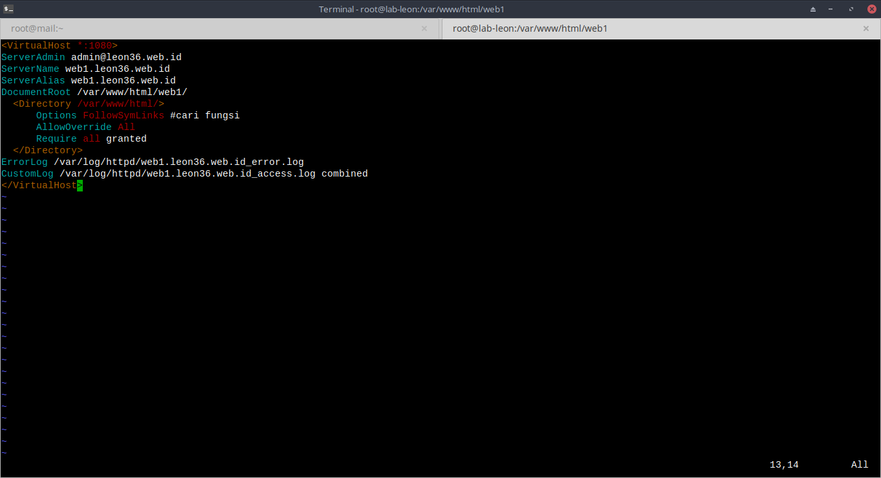
11. Buat symlink file virtualhost web1 ke dir sites-enabled
ln -s /etc/httpd/sites-available/web1.leon36.web.id.conf /etc/httpd/sites-enabled/
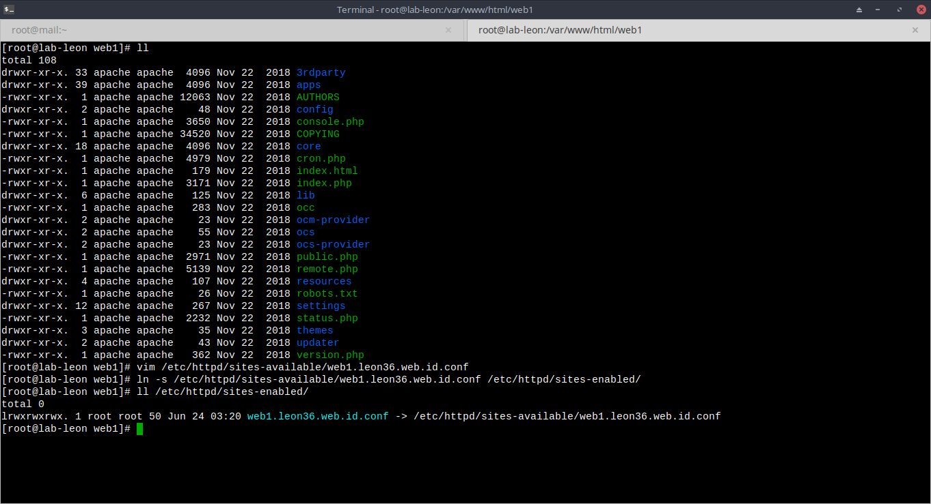
12. Restart apache
apachectl reload

13. Install nginx sebagai reverse proxy
yum -y install nginx && systemctl start nginx && systemctl enable nginx
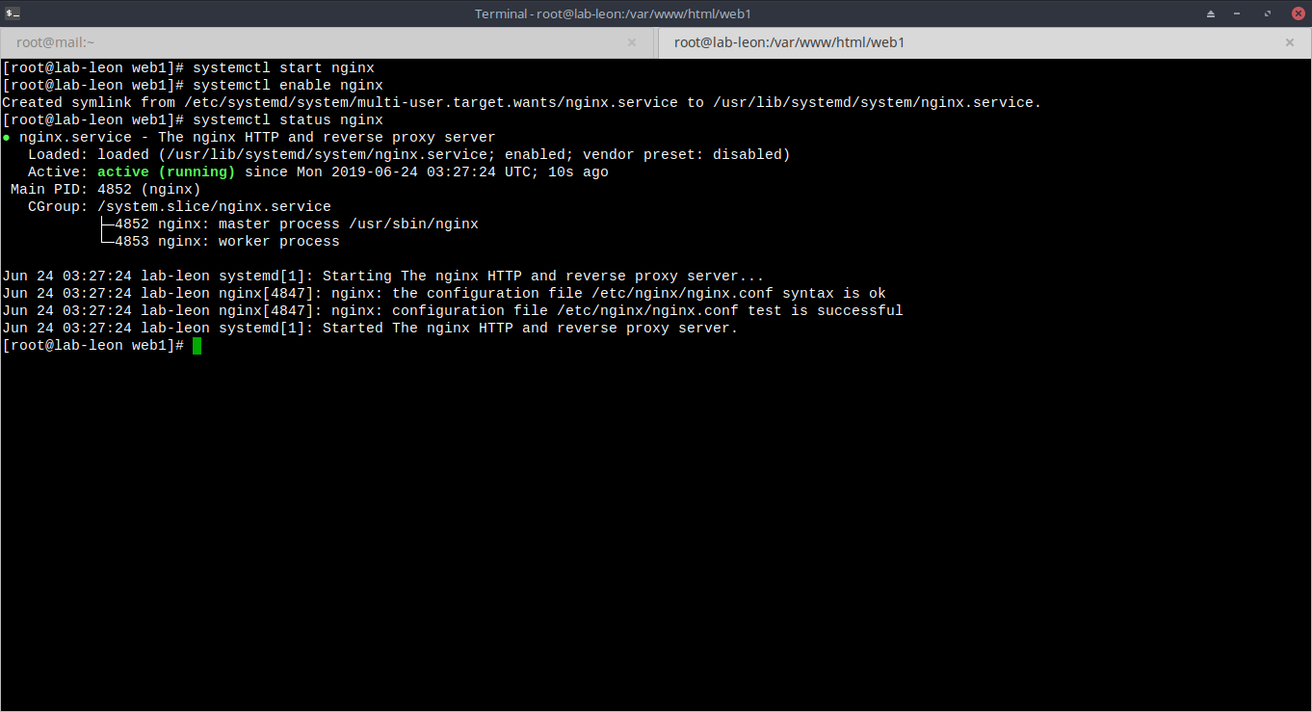
14. Buat direktori untuk konfigurasi reverse proxy web1
mkdir /etc/nginx/sites-available
mkdir /etc/nginx/sites-enabled

15. tambahkan include pada file konfigurasi nginx
vim /etc/nginx/nginx.conf
……………
#in section http
http{
......
include /etc/nginx/sites-enabled/*;
}
………………

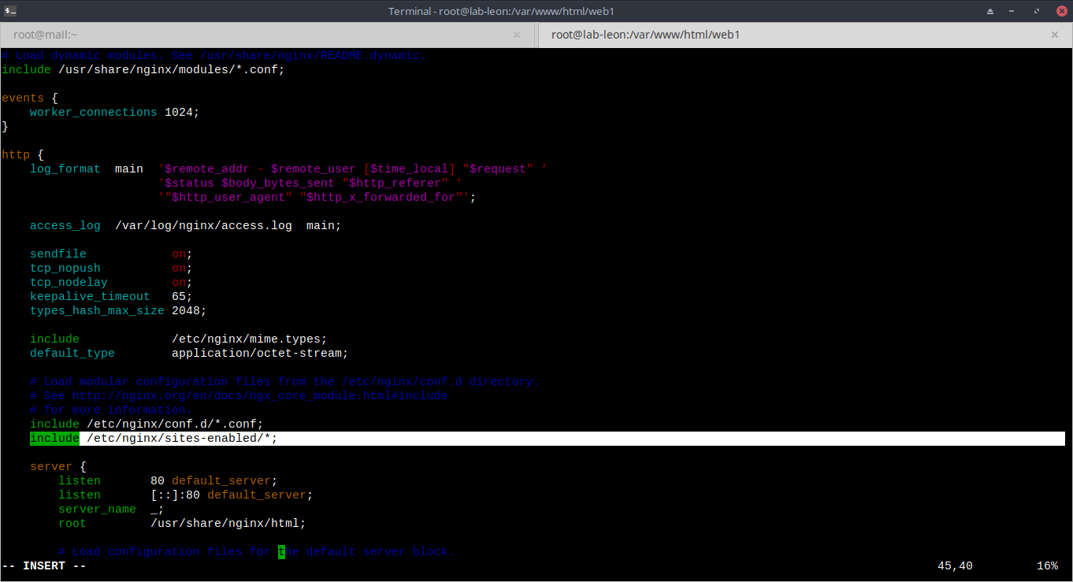
16. Buat konfigurasi reverse proxy untuk web1
vim /etc/nginx/sites-available/proxy1
…………..
listen 80;
index index.php index.html index.htm;
server_name web1.leon36.web.id;
root /var/www/html/web1;
location / {
proxy_headers_hash_max_size 512;
proxy_headers_hash_bucket_size 64;
proxy_set_header Host $host;
proxy_set_header X-Forwarded-Proto $scheme;
proxy_set_header X-Real-IP $remote_addr;
proxy_set_header X-Forwarded-For $proxy_add_x_forwarded_for;
add_header Front-End-Https on;
# whatever the IP of your cloud server is
proxy_pass http://117.53.44.123:1080;
}
…………….
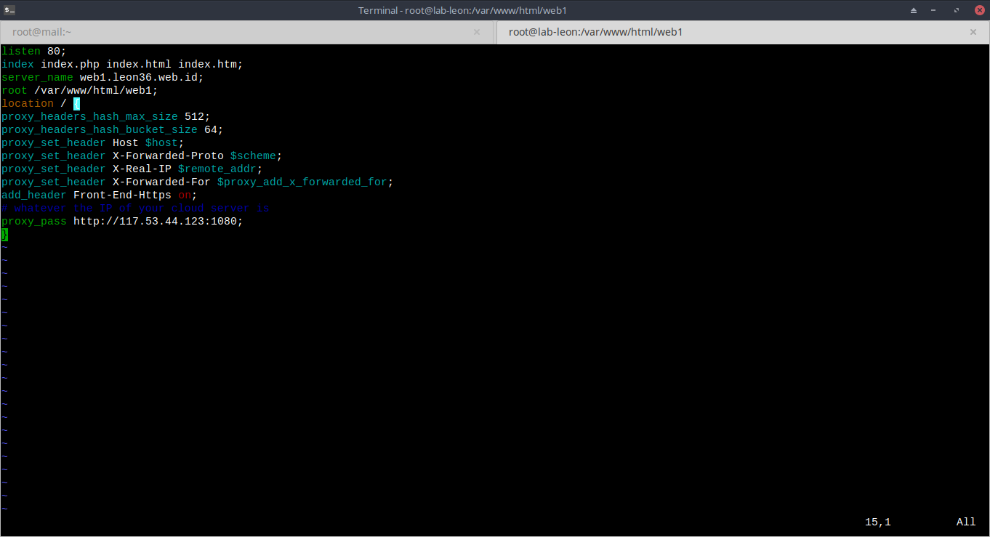
17. Tambahkan symlink untuk file konfigurasi reverse proxy ke sites-enabled
ln -s /etc/nginx/sites-available/proxy1 /etc/nginx/sites-enabled/
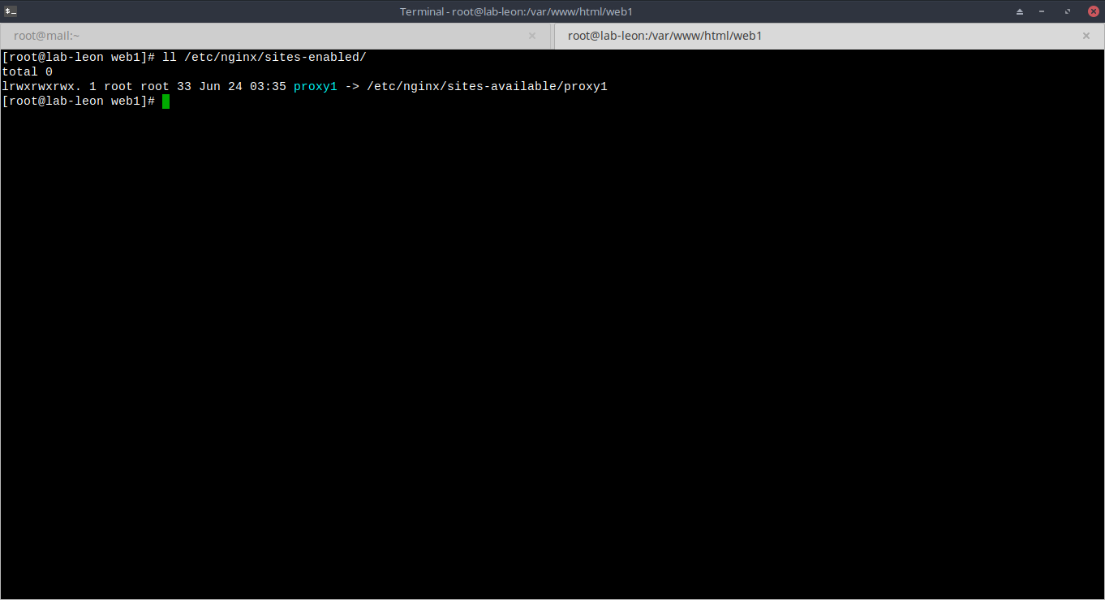
18. restart service nginx
nginx -t
nginx -s reload

19. install nextcloud pada port 1080
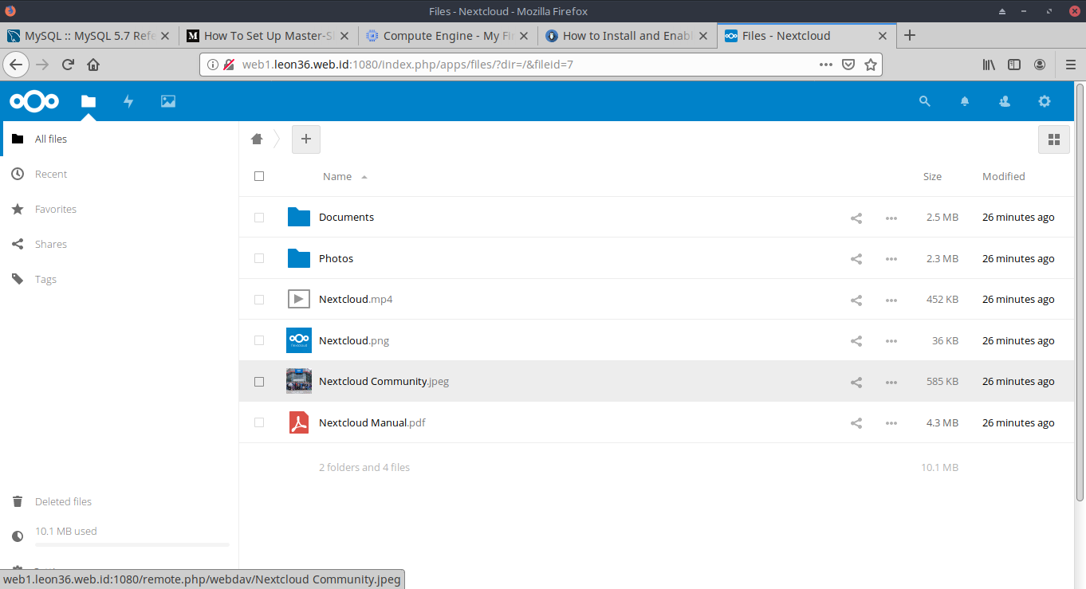
20. tambahkan trusted domain
vim /var/www/html/web1/config/config.php
………….
array (
0 => 'web1.leon36.web.id:1080',
1 => 'web1.leon36.web.id'
),
……………….
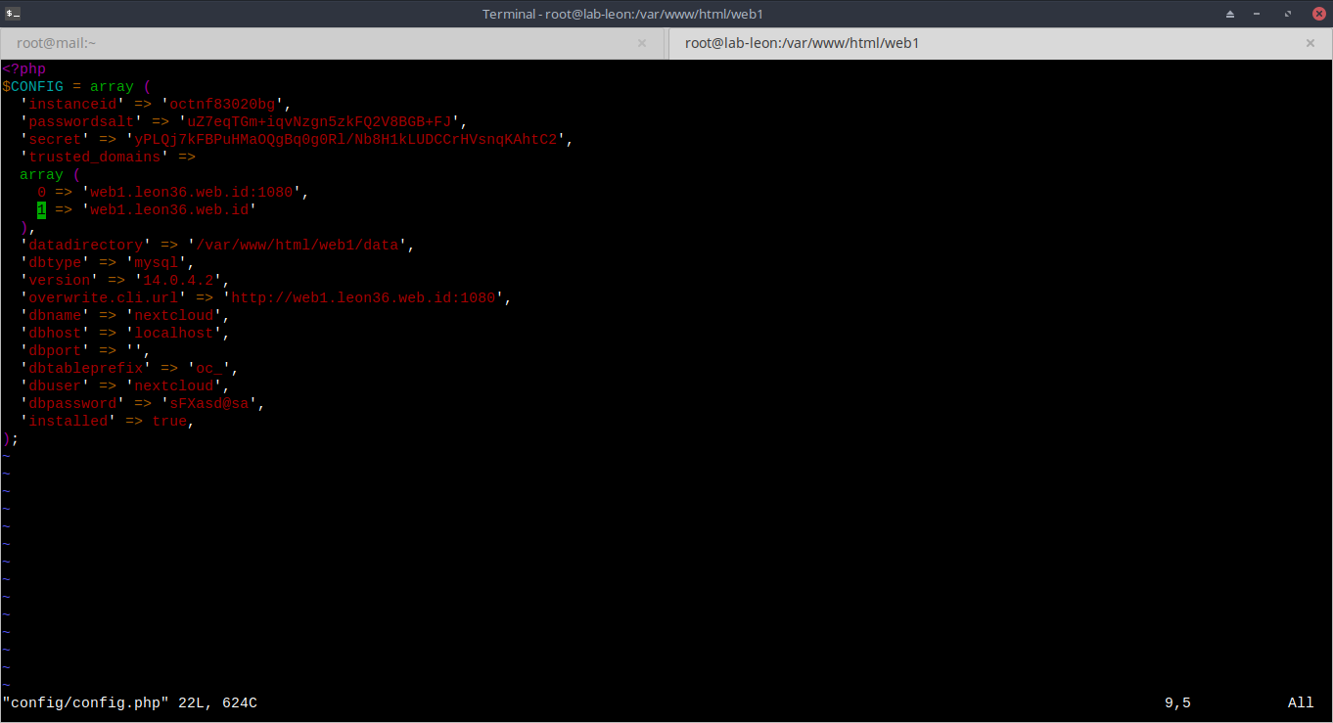
21. restart apache
apachectl restart

22. akses nextcloud tanpa port
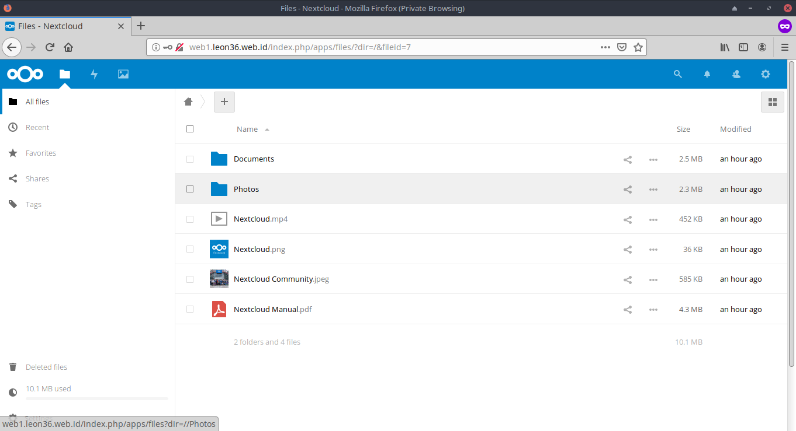
23. install composer
yum -y install composer

24. buat database magento
mysql -u root -p
create database magento;
GRANT ALL PRIVILEGES ON magento.* TO 'magento'@'localhost' IDENTIFIED BY 'aaas#$!@sasds';
FLUSH PRIVILEGES;
show databases;
exit;
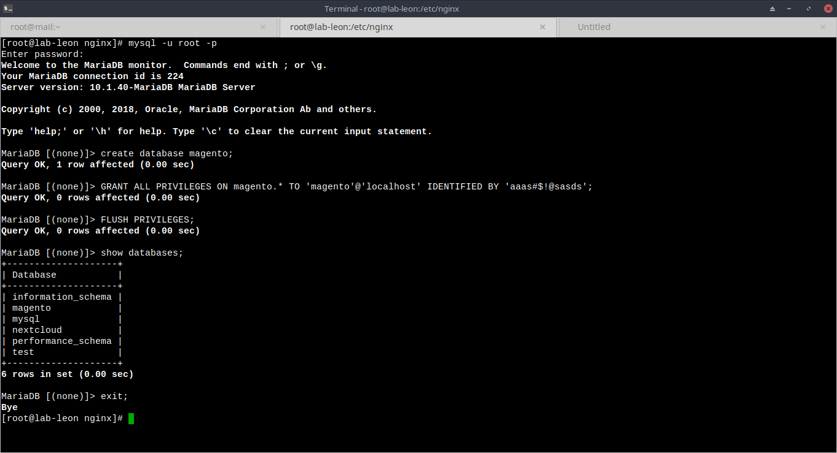
25. download magento
https://github.com/magento/magento2/archive/2.3.0.tar.gz
tar xfzv 2.3.0.tar.gz -C /var/www/html/web2

26. ganti permision dan kepemilikan dir web2
chmod -R 755 /var/www/html/web2
chown -R apache:apache /var/www/html/web2

27. Buat virtualhost untuk web2
vim /etc/httpd/sites-available/web2.leon36.web.id.conf
……………..
<VirtualHost *:1080>
ServerAdmin admin@leon36.web.id
ServerName web2.leon36.web.id
ServerAlias www.web2.leon36.web.id
DocumentRoot /var/www/html/web2
<Directory /var/www/html/>
Options FollowSymLinks #cari fungsi
AllowOverride All
Require all granted
</Directory>
ErrorLog /var/log/httpd/web2.leon36.web.id_error.log
CustomLog /var/log/httpd/web2.leon36.web.id_access.log combined
</VirtualHost>
………………..
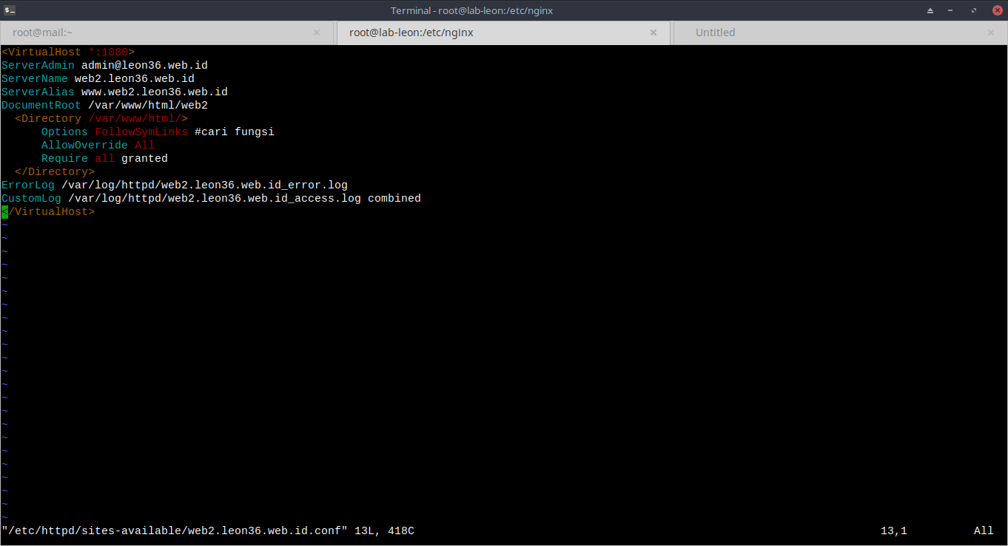
28. Buat symlink file virtualhost web2 ke dir sites-enabled
ln -s /etc/httpd/sites-available/web2.leon36.web.id.conf /etc/httpd/sites-enabled/
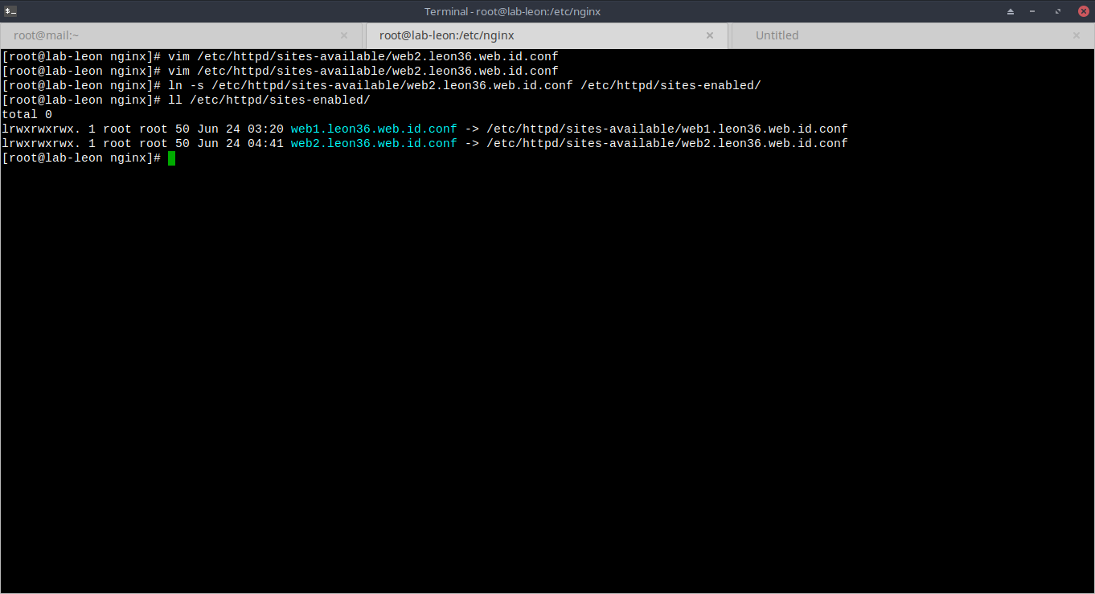
29. Jalankan komposer
composer install
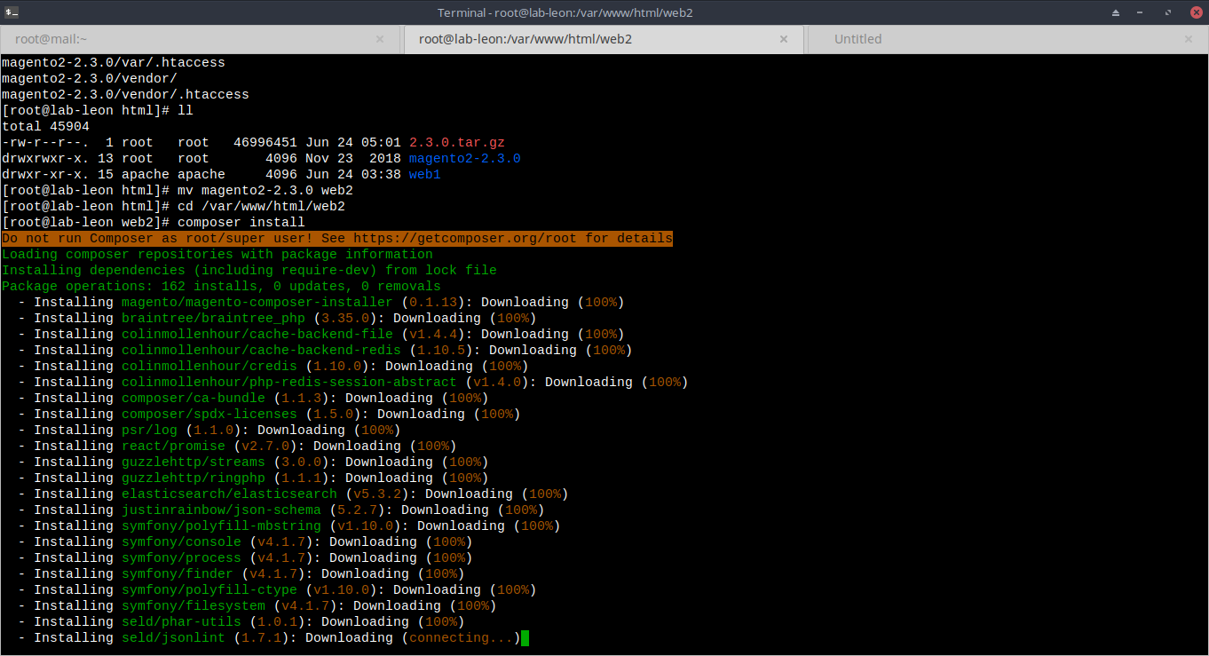
30. Buat konfigurasi reverse proxy untuk web2
vim /etc/nginx/sites-available/proxy2
……………..
server{
listen 80;
index index.php index.html index.htm;
server_name web2.leon36.web.id;
root /var/www/html/web2;
location / {
proxy_headers_hash_max_size 512;
proxy_headers_hash_bucket_size 64;
proxy_set_header Host $host;
proxy_set_header X-Forwarded-Proto $scheme;
proxy_set_header X-Real-IP $remote_addr;
proxy_set_header X-Forwarded-For $proxy_add_x_forwarded_for;
add_header Front-End-Https on;
# whatever the IP of your cloud server is
proxy_pass http://117.53.44.123:1080;
}
}
………………
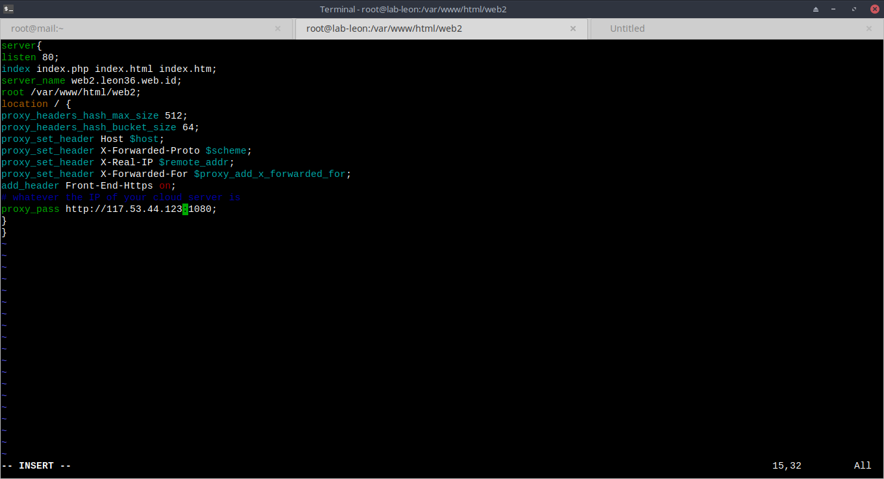
31. tambahkan symlink konfigurasi web 2 ke sites-enabled
ln -s /etc/nginx/sites-available/proxy2 /etc/nginx/sites-enabled/
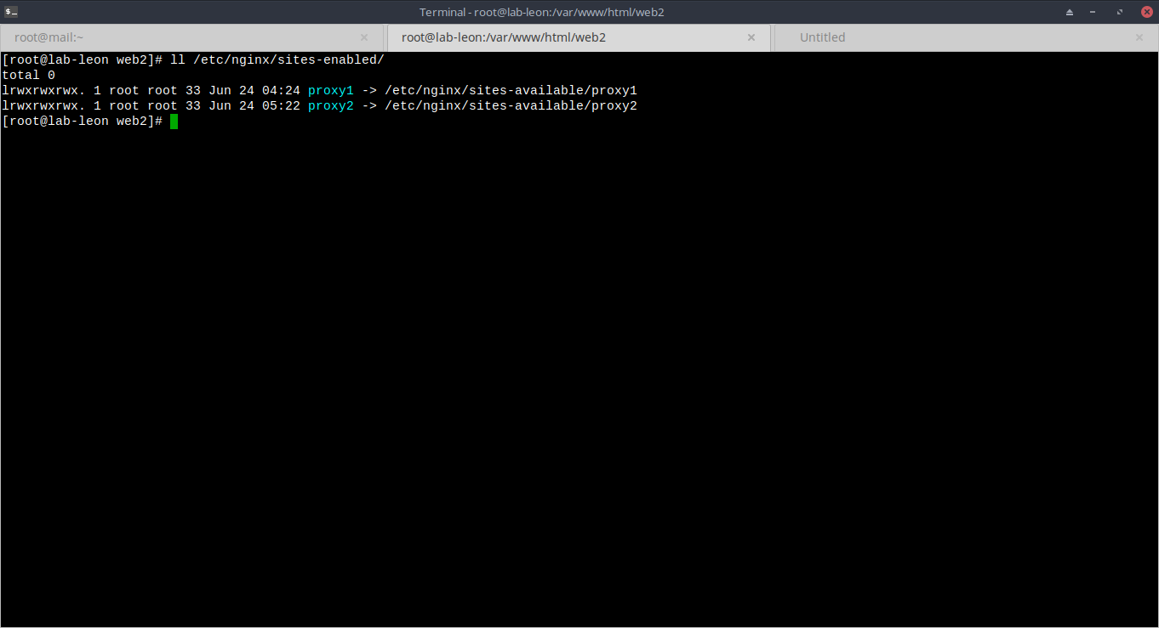
32. restart nginx dan apache
nginx -s reload
apachectl restart

33. Install magento dengan mengakses web2.leon36.web.id tanpa port
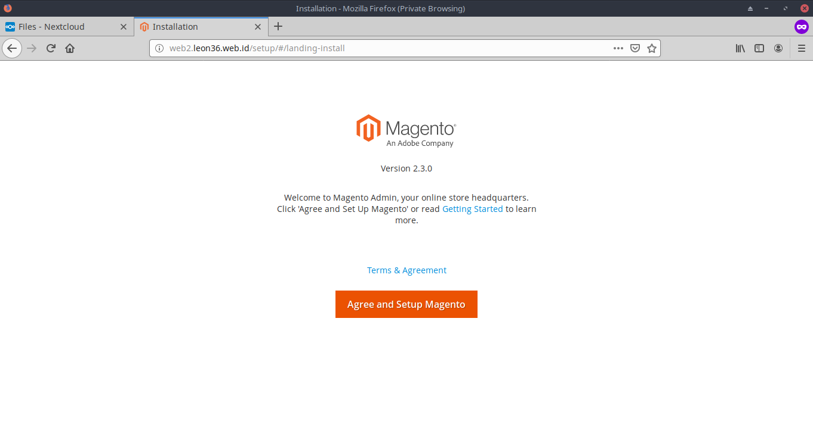
34. selesai
